Project Design Phase-II
Technology Stack (Architecture & Stack)

Date
Team ID | LTVIP2026TMIDS74706
Project Name | Empowering India: Analysing the Evolution of Union Budget Allocations for Sustainable Growth
Maximum Marks | 4 Marks

Technical Architecture:
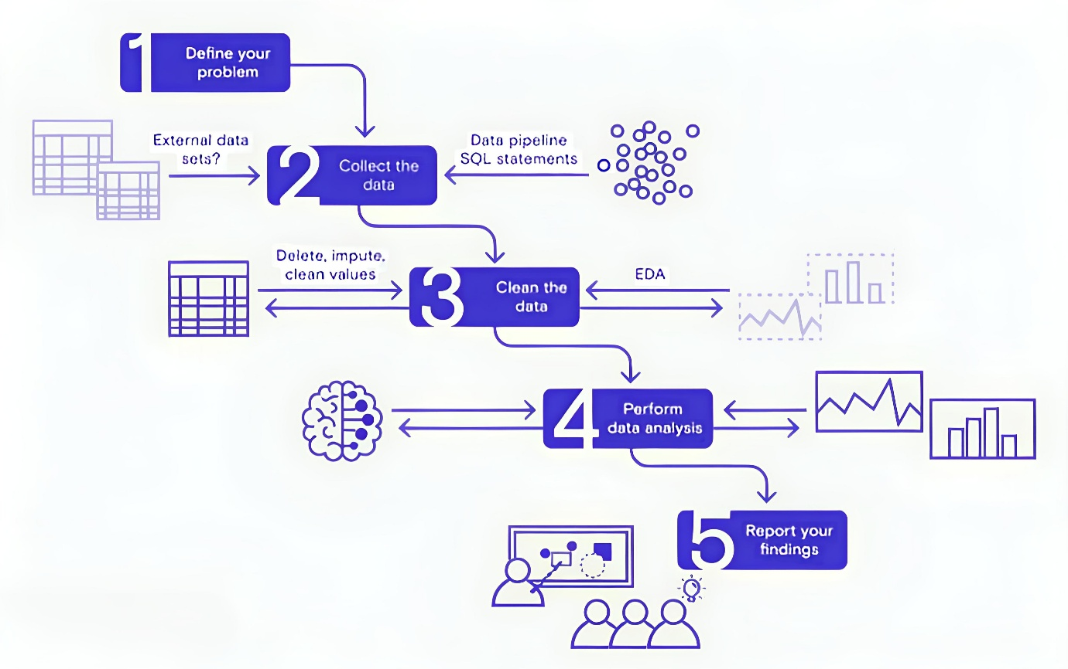

Table-1 : Components & Technologies:
S.No | Component | Description | Technology
 | User Interface | Web interface for viewing dashboards and insights | HTML, CSS, JavaScript, Tableau Public Embedding
 | Data Processing Logic | Data cleaning & preprocessing scripts | Python (Pandas, NumPy)
 | Data Storage | Stores raw data and cleaned datasets | CSV files, Google Sheets, or simple SQL/NoSQL DB (e.g., MySQL, MongoDB)
 | Visualization Layer | Creates interactive visual dashboards and charts | Tableau Public / Tableau Desktop
 | Infrastructure (Server / Hosting) | Hosts any scripts and serves embedded dashboards | Local Machine or Cloud VM (Render, Railway, or simple shared hosting)

Table-2: Application Characteristics:
S.No | Characteristics | Description | Technology
 | Open-Source Frameworks | Uses open-source Python libraries for data processing | Python (Pandas, NumPy)
 | Security | Secure storage and access to Tableau dashboards with controlled sharing | Tableau permissions, secure hosting
 | Scalable Architecture | Justify the scalability of architecture (3 – tier, Micro-services) | Technology used
 | Availability | Dashboards accessible anytime via Tableau Public or Cloud link | Tableau Public, Render, Railway
 | Performance | Dashboards use Tableau Extracts for faster load; small datasets for demo | Tableau Data Extracts, Python ETL

